**OUR LADY’S**

**SECONDARY SCHOOL**

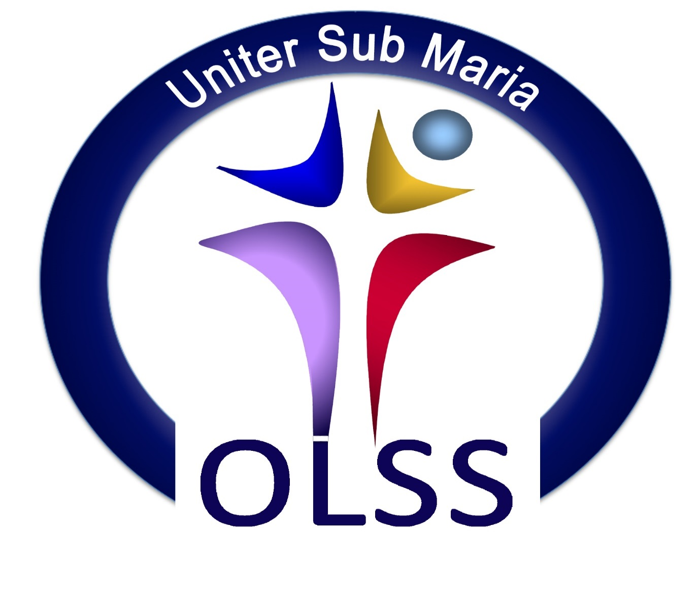

**Assessment and Reporting Policy**

**1.1 Mission Statement:**

This policy was created in accordance with Our Lady Secondary School’s Mission Statement.

*Our Lady’s Secondary School is a holistic centre of development and learning where each person is special and treated as such. We, the staff and students, enjoy working together to realise our full potential in a healthy, safe, stimulating and friendly environment where the atmosphere is one of mutual respect, cooperation and challenge. Christian community is our heritage and goal, the Good News of the Gospel is our story.*

**1.2 School Context**

Our Lady’s Secondary School is a Voluntary Catholic School under the trusteeship of CEIST. The school is Co-Educational and currently has approximately 715 students and over 55 teachers as well as a range of ancillary and support staff. The school has a Board of Management comprised of Trustee Nominees, Teacher Nominees and Parent Nominees. The Board of Management delegates the day-to-day running of the school to the Principal. The school supports the principles of inclusiveness, equality of access and parental choice in relation to enrolment. In supporting these principles it also recognizes\is cognizant of the rights of the Trustees CEIST, the Religious and Educational Philosophy of the Sisters of Mercy and the funding and resources available.

**1.3 Mercy Philosophy of Education**

Inspired by the vision of Catherine McAuley, Mercy Education is committed to holistic development and to the achievement of the full potential of each student, particularly those who are disadvantaged or marginalised. It is a process informed and influenced by the teaching and example of Jesus Christ and is conducted in an atmosphere of care, respect and joy. Mercy Education is committed to ongoing whole school development in collaboration and partnership with the Board of Management, Staff, Students, Parents/Guardians and the wider community.

**1.4 CEIST Core Values**

The Core Values of CEIST are:

* Promoting Spiritual & Human Development
* Achieving Quality in Teaching and Learning
* Showing Respect for Every Person
* Creating Community
* Being Just and Responsible

**1.5 Rationale for Policy**

The Education Act (1998) requires schools to regularly evaluate students and periodically report the results of the evaluation to students and their parents. In fulfilling this requirement, schools develop assessment procedures, which provide an accurate account of a student’s progress and achievement. This policy deals with assessment practices within our school and how assessment is reported on.

The manner in which assessment takes place has changed in recent years with reforms in Junior Cycle. The introduction of Classroom Based Assessments in particular is a new development. Our Assessment Policy reflects curricular changes mandated by the Department of Education of Skills and the National Council for Curriculum and Assessment (NCCA) including the Junior Cycle Profile of Achievement (JCPA) and Senior Cycle syllabi. Aside from these changes, the manner in which teachers conduct day-today assessment is changing as formative assessment becomes more embedded in teachers’ practice.

This policy aims to:

* Explain the rationale and importance of assessments to parents, students and teachers
* Highlight the different types of assessment that take place in Our Lady’s Secondary School (formative and summative)
* Outline the annual schedule of assessments (summative)
* Indicate the reporting procedures adopted post assessments
* Codify norms of behaviour expected in the area of assessment.

**1.6. Other policies that should be read in conjunction with this policy**

* Homework Policy
* Special Education Needs Policy
* Guidance Policy
* Curriculum Policy
* Transition Year Plan
* Circular Letter 0079 /2018
* Circular 0058/2019

**Definitions & Types of Assessment**

The term “Assessment” is defined as the gathering and interpretation of information related to a student’s learning abilities, learning attainment, learning strengths and learning needs. Assessment generates important information about how a learner is progressing. This information can be shared with students in the form of feedback which should help the learner to become more aware of his / her own strengths and weaknesses, and identify next steps and strategies for improvement.

There are two main types of assessment, firstly assessment for learning which is formative in nature, involves continuous assessment and occurs during the learning process. Examples include student self-assessments, portfolios and reflections. Secondly, assessment of learning, which is summative in nature and takes place after the learning has occurred. Examples include House Exams and State Exams. In Our Lady’s Secondary School we strive to combine a balance of both types of assessment to facilitate rich student learning experiences. The table below distinguishes between both types of assessment.

|  |  |
| --- | --- |
| **Assessment OF Learning (Summative)** | **Assessment FOR Learning (Formative)** |
| * Happens after learning takes place | * An integral part of learning process |
| * Information is gathered by teacher | * Information is shared with learner |
| * Information is usually transferred into marks e.g. State Exams | * Information is available on quality of learning e.g. features of quality in classroom-based assessments. |
| * Comparison with performance of others | * Is linked to learning outcomes and success criteria |
| * Looks back on past learning | * Looks forward to the next stage of learning |

**Assessment for learning (AfL)** is diagnostic, on-going and formative. Our Lady’s Secondary School supports the Assessment for Learning (AFL) approach to formative assessment. Its purpose is to use the whole process of assessment to help learners improve their learning. It is formative because its intention is to form, shape or guide the next steps in learning.

* It reflects a view of learning in which assessment helps students’ “learning to learn”.
* It involves both teacher and student in a process of continual reflection and review.
* It is for on-going planning and can involve teacher assessment, student self-assessment and student peer-assessment.
* It is criterion-referenced with the criteria based on prescribed learning outcomes identified in the curriculum/syllabus, reflecting performance in relation to a specific learning task. The criteria for success is shared with the learner.
* It involves providing feedback, which helps students to recognise what they must do to close any gaps in their knowledge or understanding
* Teachers adjust their plans and engage in corrective teaching in response to formative assessment.

**Assessment of Learning** is summative and is used for the purpose of providing evidence of achievement for grading or reporting.

* It is teacher assessment and may be either criterion-referenced (based on Learning Outcomes) or norm-referenced (comparing student achievement to that of others)
* Information on student performance can be shared with parents, and with other teachers when engaging in curriculum development e.g. school reports
* AoL can be used to make judgments about a students’ performance in relation to national standards.

**The relationship between AfL and AoL:** if the goal of learning is to achieve deep understanding, then formative assessment should identify problems and progress toward that goal, and summative assessment should measure the level of success at reaching that goal. They are different stages of the same process and should be closely tied together in design and purpose.

**Purpose of Assessment**

**Assessment enables Students:**

* To improve their achievement
* To become actively involved in their own learning
* To be motivated to achieve to their full potential
* To become self-directed and autonomous learners
* To engage in reflection and self-assessment
* To develop an awareness of how to look at their own work in a reflective way, identify aspects of it that are good and that could be improved, and then set personal learning targets for themselves.

**Assessment enables Teachers:**

* To assess progress and adapt planning as required
* To evaluate their pupils’ learning needs
* To ensure that pupils know how to improve the standard of their work
* To evaluate teaching and learning styles and outcomes
* To monitor a student’s progress and to provide the teacher with information to make decisions about what and how the student is learning. This information allows the teacher to identify the next steps in progressing the students learning and adapt his/her teaching strategies and/or learning activities as appropriate.
* To provide the students and parents with information regarding progress
* To establish baseline data in relation to a student’s attainments in certain subjects
* To assess a student’s eligibility for additional support and services and to inform consultations with external agencies e.g NEPS Psychologist where necessary.

**Assessment should enable Parents:**

* To be involved in their son / daughters learning
* To understand and encourage the progress their son / daughter is making
* To check their son /daughter’s progress throughout their time in Our Lady’s
* To gain an insight into the broad spectrum of assessments undertaken by students
* To be informed about their son / daughter’s academic progress through reports and Parent-Teacher meetings.

**Range of Assessment Experiences at Junior Cycle**

**First Year**

* Homework which may include written, oral, aural, reading, project or portfolio work is assigned regularly.
* Engage in Assessment for Learning (AfL) strategies with the purpose of progressing student learning to the next stage.
* Formative feedback from teachers both verbal and written feedback, which may include comments and/or grades.
* Student Journal – the teacher can communicate the outcome of any assessment during class time to parents/guardians by writing the result or a note in the student journal.
* First Year students receive reports in January and June after completing Christmas class tests and Summer House Exams and parents / guardians can check and monitor student progress via ePortal. Subject teachers in First Year agree on a common test and have a common marking scheme that includes one alternative method of assessment other than a written exam.
* The Guidance Counsellor and First Year, Year Head will meet with the link person from Senior Management to monitor and review student progress and appropriate interventions and supports will be put in place.

**Second Year**

* Homework which may include written work, oral presentations, research, aural, reading, project or portfolio work is assigned regularly.
* Engage in Assessment for Learning (AfL) strategies with the purpose of progressing student learning to the next stage.
* Formative feedback from teachers both verbal and written feedback including comments and/or grades.
* Student Journal – the teacher can communicate the outcome of any assessment during class time to parents/guardians by writing the result or a note in the student journal.
* Second Years undertaking new Subject Specifications for the Junior Cycle Profile of Achievement complete the first classroom-based assessment (CBA). Classroom-Based Assessments are best described as the occasions when the teacher assesses the students using the specific tasks set out in the subject specification e.g. oral presentation in English or the Business in Action Group Project in Business Studies or the Extended Experimental Investigation in Science.
* The criteria for assessment are found in the features of quality linked to each Classroom-Based Assessment. Although the assessment is similar to the formative assessment that occurs every day in class, in the case of Classroom-Based Assessment the teacher’s professional assessment is recorded for Subject Learning and Assessment Review, and is subsequently used in the school’s reporting to parents and students.
* Second Year students receive reports in January and June after completing Christmas and Summer House Exams and parents / guardians can check and monitor student progress via ePortal.
* The Guidance Counsellor and Second Year Year Head will meet with the link person from Senior Management to monitor and review student progress and appropriate interventions and supports will be put in place.

**Third Year**

* Homework which may include written work, oral presentations, research, aural, reading, project or portfolio work is assigned regularly.
* Engage in Assessment for Learning (AfL) strategies with the purpose of progressing student learning to the next stage.
* Formative feedback from teachers both verbal and written feedback including comments and/or grades.
* WRAT4 and CAT4 are completed to support RACE applications where required (The WRAT4 is a norm referenced test that measures the basic academic skills of word reading, sentence comprehension, spelling and maths computation).
* Third Year students complete the practical components in certain subject areas.
* Third Year students undertaking new Subject Specifications for the Junior Cycle Profile of Achievement complete the second classroom-based assessment (CBA). Examples of the second CBA due for completion in 3rd Year include; the Collection of Student’s Texts in English, the Science in Society Investigation and an individual presentation in Business Studies on a Business topic or business related issue of local or personal relevance.
* The criteria for assessment are found in the features of quality linked to each Classroom-Based Assessment. Although the assessment is similar to the formative assessment that occurs every day in class, in the case of Classroom-Based Assessment the teacher’s professional judgment is recorded for Subject Learning and Assessment Review, and is used in the school’s reporting to parents and students.
* Third Year students complete an Assessment Task for new subject specifications. The Assessment Task is a written task completed by students during class time, which is not marked by the class teacher, but is sent to the State Examinations Commission for marking. The Assessment Task is specified by the NCCA and is related to the learning outcomes on which the second Classroom-Based Assessment is based.
* Student Journal – the teacher can communicate the outcome of any assessment during class time to parents/guardians by writing the result or a note in the student journal.
* Third Year students receive reports in October, January and after completing their Pre-Examinations in February/March. Parents / guardians can check and monitor student progress via ePortal.
* All Third Year students will be assigned a link person from the Senior Management, Student Support Team or the Council of Discipline. This person will formally meet with the students on a regular basis to monitor their progress and set targets.

**Assessment & Reporting in the New Junior Cycle of Achievement**

As the new subject specifications are rolled out up to 2022, they will continue to be examined by the State Examinations Commission (SEC) in June of third year, however each subject exam paper will be no longer than 2 hours in the case of new specifications. The results will form part of each student’s Junior Cycle Profile of Achievement (JCPA), which will offer a more complete report on progress during junior cycle. The JCPA will also include descriptors awarded for levels of achievement in classroom-based assessments, short courses and other learning experiences. The Assessment Task mark will be included in the final examination grade and both are graded by the SEC. The grading of new subjects will be as follows in State Exams:

**Grading of the Final Examination**

* Distinction ≥90% to 100%
* Higher Merit ≥75% and <90%
* Merit ≥55% and <75%
* Achieved ≥40% and <55%
* Partially Achieved ≥20% and <40%
* (not graded) ≥0% and <20%

**Grading Classroom-Based Assessments**

Classroom-Based Assessments in all subjects will be specified at a common level and marked by the teacher. CBAs will be undertaken by students within class time to a national timetable. When assessing the level of student achievement in a Classroom-Based Assessment the Features of Quality, are used to assign one of the following four descriptors.

**Classroom-Based Assessment Descriptors**

* Exceptional
* Above Expectations
* In Line with Expectations
* Yet to Meet Expectations

**Level 2 Learning Programme (L2LP)**

The Level 2 Learning Programme is specifically designed for students with a high moderate- low mild general learning difficulty. Each student must experience a minimum of three years completing all elements of five PLU’s (Priority Learning Units) and two short courses. The assessment of Level 2 Learning Programme is school based and ongoing. Students must create a portfolio of evidence to display their achievement of learning outcomes for each of the five Priority Learning Unit and two short courses. The purpose of ongoing assessment allows the student to demonstrate their strengths and skills. There will be no formal written exam. This evidence will demonstrate their achievement of learning over the three years.

**Junior Certificate Schools Programme (JCSP)**

The Junior Certificate Schools Programme offers a differentiated curriculum to support the student in accessing the curriculum content of the Junior Cycle. Similar to the Level 2 Learning Programme, students must produce a portfolio of evidence to display their understanding and achievement of the statements of learning. At the end of the three year programme students will receive a profile which is an official record of their achievements for the Department of Education and Skills.

**Transition Year Assessment Experiences and Reporting**

* Rich learning experiences and personal development are the hallmarks of the Transition Year Programme in Our Lady’s Secondary School.
* Participation in TY events and activities is continuously assessed
* Engage in Assessment for Learning (AfL) strategies with the purpose of progressing student learning to the next stage, promoting personal growth, developing self-confidence, discovery learning and embracing leadership and learning.
* Focus on Eportfolio assessments, reflective journaling, learning logs, oral presentation, multi-media, self and peer assessments.
* TY students compile their Eportfolios over the course of the year. Students’ articulate their personal learning milestones, examples include Induction Activities, School Musical, Young Scientist, Work Experience, YSI, Mini-Company, Gaisce, Build a Bank and so many more.
* Homework which may take the form of written work, oral presentations, research, aural, reading, project or portfolio work is assigned regularly.
* Transition Years and their parents/guardians receive an overview of the students’ rich learning experiences at the TY Awards Night in May.
* Student Journal – the teacher can communicate the outcome of any assessment during class time to parents/guardians by writing the result or a note in the student journal.
* TY students receive a report in January and June following their exams and parents / guardians can check and monitor student progress via ePortal.
* The Guidance Counsellor and Fourth Year Year Head will meet with the link person from Senior Management to monitor and review student progress and appropriate interventions and supports will be put in place.
* ***For a more detailed overview of assessment procedures in Transition Year please consult the Transition Year plan.***

**Leaving Certificate Applied Assessment Experiences and Reporting**

* LCA is a distinct, self-contained two-year Leaving Certificate programme aimed at preparing learners for adult and working life.
* Work experience, continuous assessment and personal development are key features of the LCA Programme in Our Lady’s Secondary School.
* Prepares learners for the transition to adult and working life.
* Recognises talents of all learners and our LCA programme is responsive to aptitudes, abilities, needs and interests.
* Provides opportunity to develop in terms of responsibility, self-esteem and self-knowledge.
* Develops communication and decision making skills.
* Helps learners achieve a more independent and enterprising approach to learning and to life.
* Continuous assessment through a combination of practical project work, tasks and coursework and key assignments.
* Students engage in Assessment for Learning (AfL) strategies with the purpose of progressing student learning to the next stage.
* Formative feedback from teachers both verbal and written feedback including comments to assist students in improving their work.
* 90% attendance requirement for successful completion of modules and award of credits.
* Each Task is weighted at 10 Credits and following task examinations SEC grades are posted to the school and results are shared with students.
* LCA students are required to complete a number of key assignments per module and must sign-off on all key assignments in their LCA School Journals as a record of completion.
* Credits are awarded for successful completion of key assignments and tasks.
* LCA students receive written report in January and June.
* School Award of Credits- 62 credits (31%)
  + Satisfactory completion of modules
  + 90% attendance
* 7 Student Tasks (6 require an interview with an external examiner)- 70 credits (35%)
* SEC Final Exams- 68 credits (34%)
* The overall LCA certificate is awarded at 3 levels
  + Pass 120-139 credits
  + Merit 140-169 credits
  + Distinction 170-200 credits

**Fifth Year Assessment Experiences and Reporting**

* Homework which may take the form of written work, oral presentations, research, aural, reading, project or portfolio work is assigned regularly.
* Engage in Assessment for Learning (AfL) strategies with the purpose of progressing student learning to the next stage.
* Formative feedback from teachers both verbal and written feedback including comments and/or grades.
* Project work for Leaving Certificate subjects
* WRAT-IV and CAT-IV for RACE applications where required.
* Student Journal – the teacher can communicate the outcome of any assessment during class time to parents/guardians by writing the result or a note in the student journal.
* Fifth Year students receive reports in January and June after completing Christmas and Summer House Exams and parents / guardians can check and monitor student progress via ePortal.
* The Guidance Counsellor and Fifth Year Year Head will meet with the link person from Senior Management to monitor and review student progress and appropriate interventions and supports will be put in place.

**Sixth Year Assessment Experiences and Reporting**

* Homework which may take the form of written work, oral presentations, research, aural, reading, project or portfolio work is assigned regularly.
* Engage in Assessment for Learning (AfL) strategies with the purpose of progressing student learning to the next stage.
* Formative feedback from teachers both verbal and written feedback including comments and/or grades.
* Sixth year students engage in a range of formal and informal assessments.
* The Pre-Examinations are January / February
* The Leaving Certificate State Exams are in June.
* Project or practical course work for Leaving Certificate subjects.
* Preparation for and completion of the oral component of Irish, German or French.
* Student Journal – the teacher can communicate the outcome of any assessment during class time to parents/guardians by writing the result or a note in the student journal.
* Sixth Year students receive reports in September, October, January and after completing their Pre-Examinations in February/March. Parents / guardians can check and monitor student progress via ePortal.
* All Sixth Year students will be assigned a link person from the Senior Management, Student Support Team or the Council of Discipline. This person will formally meet with the students on a regular basis to monitor their progress and set targets.

**The New CAO Common Points Scale for Leaving Certificate from 2017**

From 2017 onwards the number of grade bands were reduced from 14 to 8 are now called H1 to H7 or O1 to 07. The Common Points Scale is detailed below and reflects the reduction in grade bands. All applicants will be competing using the same scale.

The mechanics of the CAO application and offer process will remain the same; applicants must meet the minimum entry requirements, and places will be awarded based on an applicant’s position on the order of merit list. 25 bonus points will continue to be awarded for Higher Level Mathematics for H6 and above.

* H1 / O1 90 – 100
* H2 / O2 80 < 90
* H3 / O3 70 < 80
* H4 / O4 60 < 70
* H5 / O5 50 < 60
* H6 / O6 40 < 50
* H7 / O7 30 < 40
* H8 / O8 0 < 30

**LCVP**

LCVP is assessed by (60%) a portfolio of coursework and (40%) a terminal exam.

The structure of the Written Examination is as follows:

* Section A Audio Visual Presentation
* Section B Case Study (received in advance by students)
* Section C General Questions (4 out of 6)

The Portfolio of Coursework accounts for 60% of total marks. Students assemble the portfolio over the two years of the programme and it is assessed at the end of the final year of the Leaving Certificate.  The Portfolio and Written Examination are externally assessed by the State Examinations Commission.

There is a pre (Mock) examination in LCVP in 6th year. In 5th and 6th year students receive written reports in line with other subjects. In class, assessment is predominately formative with a summative element mostly, but not exclusively, in the form of class tests.

**3.3 Reasonable Accommodation for State Examinations**

The application for RACE is made by the SEN Department and the Principal on behalf of the parent/pupil. Psychological and medical reports that recommend reasonable accommodation for certain students will be followed up on, however in making any application the school has to fulfil the criteria as established by the SEC and Department of Education & Skills. All Applications fulfilling the SEC criteria will be forwarded to the ‘Reasonable Accommodation’ section of the State Examinations Commission. The State Examinations Commission has very clear criteria from which application can be sought here in relation to Reasonable Accommodation which can be accessed on the following website www.examinations.ie

**Other Forms of Assessments *(for a more detailed view on Entrance Tests, DATS Tests etc please refer to the Guidance Policy)***

**Entrance Assessments:**

Incoming First Year students will undertake the CAT 4 prior to entrance for the purpose of screening and to identify any student who needs to be further investigated for the possible provision of additional supports or interventions. It measures the four principal areas of reasoning – verbal, non-verbal, quantitative and spatial. This assessment offers an early indicator to the school of a student’s potential and learning preferences across a range of learning areas.

**Maths and Reading Age Tests:**

All students in First, Second and Third year will be tested to assess their reading and mathematical ability each academic year. The group tests highlights students’ strengths and weaknesses, helping teachers to address areas of concern and build upon what they already know in order to increase their understanding. This information will provided valuable data for the purpose of SSE target setting and school interventions to support identify students, e.g. literacy/ spelling programmes, etc,

**Aptitude Tests:**

Fifth Year students will complete a Differential Ability Test (DATs) to assist in their investigation of possible college and career choices. The results of these tests indicate a student’s performance across the following learning areas on the day of the test: verbal reasoning, numerical reasoning, abstract reasoning and language usage. It is important to recognise that, where DATs are useful in indicating the level of students’ aptitudes in various areas, DATs do not take into consideration all intelligences: Interpersonal, Intrapersonal, Aesthetic, Artistic, Musical, Spiritual or Kinaesthetic.

**Academic Tracking Programme**

The primary goal of this programme is to ensure that every student in our care reaches their full potential academically. Individual students’ academic progress is tracked, taking into account results of their standardised tests, house exams, mock exams and state exams (and other assessments, where relevant). All parents have online access to their sons/daughters’ academic records. Senior Management work in collaboration with teachers to ensure that individual students’ academic results are recorded and shared as appropriate, and used to monitor progress and set improvement targets for students.

Policy Ratified: December 17th 2019

Chairperson of the Board of Management: Gary Carville

Review Date: June 2021